JIRA—

<https://www.atlassian.com/software/jira/download>

[rumabddl123@gmail.com](mailto:rumabddl123@gmail.com)

id-jira123

pwd-

Action –

BAFO-K1AN-ZL3L-JIIG

1. Create a project
2. Create a user
3. Assign the user to the project [project back log,sprint backlog]

============================================

**Step 1-Create a Project – Go to projects> Select> click on Create project**

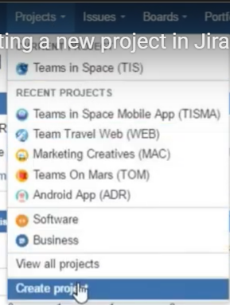

**Then this screen will come > Select like Scrum software development> Next**

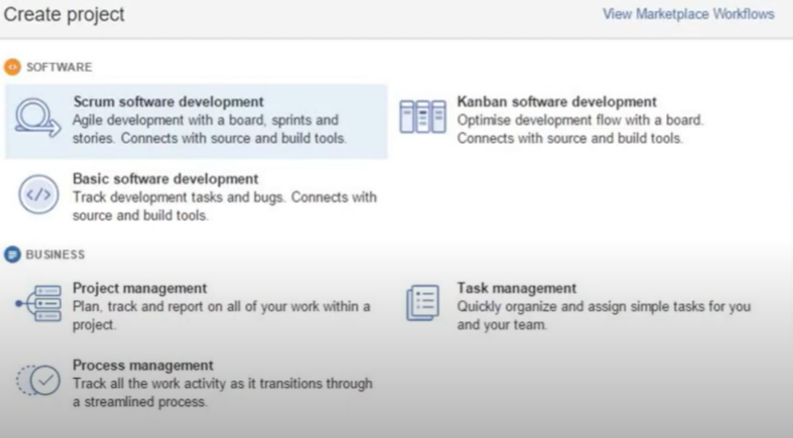

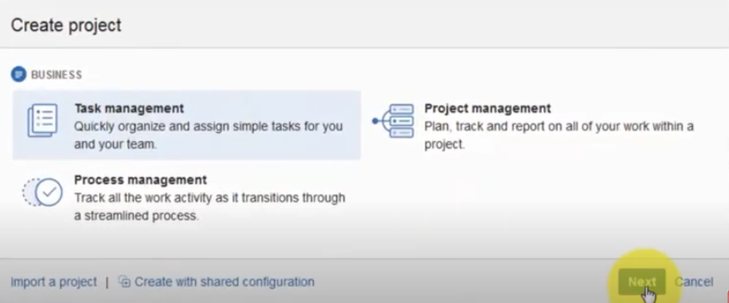

**To comfirm the project > then Click next**

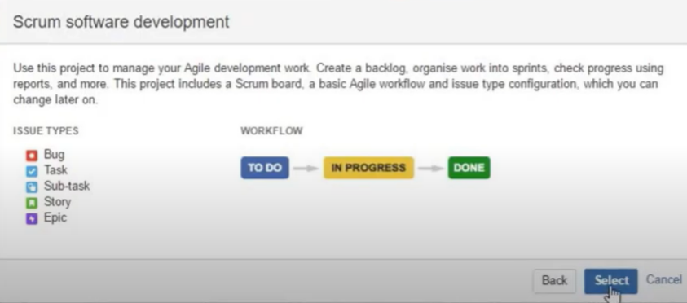

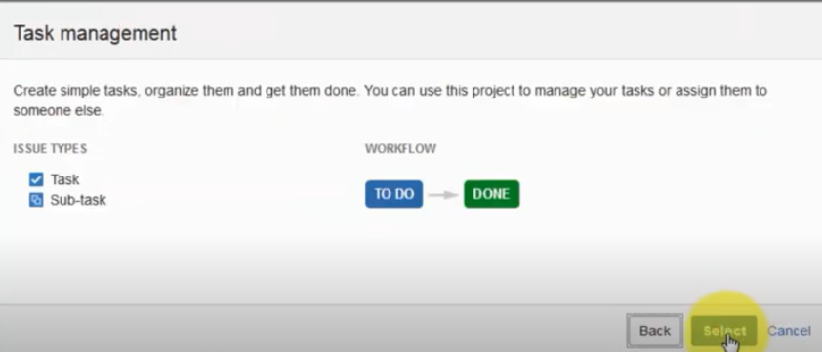

Give the Project name like Inventory Management System or like in case of Scrum software development – Teams in Space Mobile,> Click on Submit.

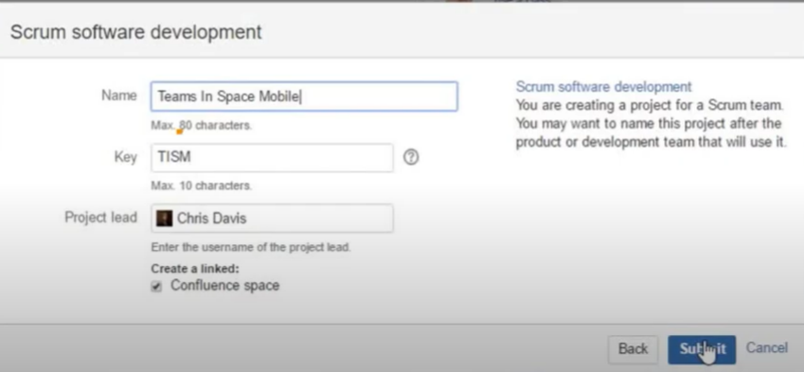

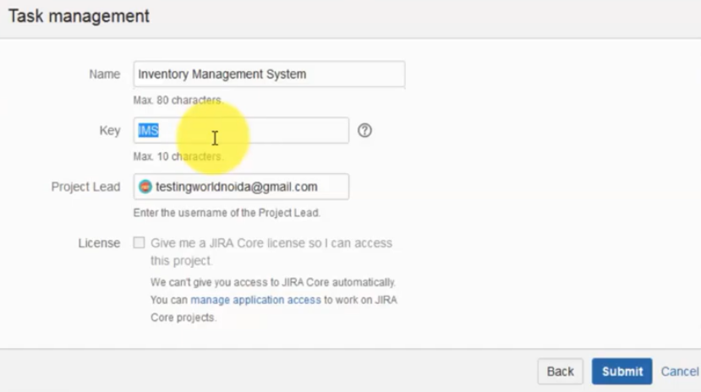

**Step -2 > Then you need to create a new user. -So go to UserManagement > then Create a new user giving uname, pwd email then click on create user.**

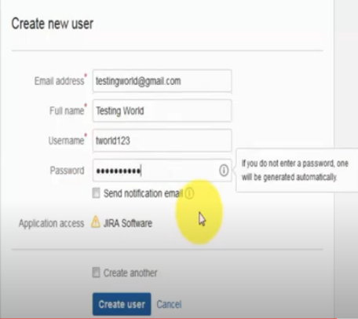

**So Create a Project and create a user is done .**

**Step -3**

**Then assign this user to the project.**

**Then Assign the user to the project . So click on project again in the same page> Then click on project which you creates >**

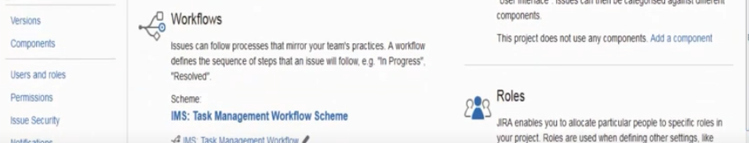

**then go the users and Roles and click on it > Add a user [right corner up] then user is allocated to the project.**

**So finally Project, user ,and assign user to the project is done.================Now Ready to test Jira Rest Services**

**==================================================================================**

**JIRA API for Different Tasks**

**==================================================================**

Bug Reporting in JIRA

**Question -  How we can report a defect into the JIRA?**

**Important notes**

Like My Application name is Testing.Com.

First I have to confirm the bug.

Here the functionality is as I select category and subcategory.So subcategory as we selected it should display 10 results.but we are not getting 10 results. we are getting only 4 results. So that this is a bug. I want to report this defect.

**Step 1- Login as a Software Tester.**

**Step – to create a new defect-> go to create button**

1. To create defect > First type project name > then select issue type that is bug , because I want to report a bug.
2. Summary—like **[giving basic information about a defect**]

**Searching Category and SubCategory does not display correct search result** or/ **searching course does not display correct search result.**

1. Component -It is a module.so these components are entered by the admin.

we will just get all the components which are added by the admin. we can select that component. we can understand it module.

1. Description- we need to give complete description about the defect.Like
2. Description :---

While testing course search functionality, as we select category and subcategory and click on search, we are not getting expected output.

Steps to reproduce

1. Go to application
2. Select category =software testing
3. Select subcategory= Agile
4. Click on such button

Expected Result is **:** It should display 10 results and

Actual **:** we are getting 4 results



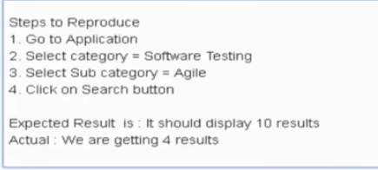

**Steps to reproduce that is one of the most important factor while reporting a new defect.**

1. Fix Version---
2. Priority -give the priority – like High.
3. Environment in which environment you are facing issue.So I am facing this issue on Firefox 25.
4. Affects version/s-current version is v1 on which I am
5. Linked issues-
6. Issue
7. Assignee -it is praciSo I don't know which developer is going to fix that.so I'm not assigning it.

M) Epic link-

1. Attachment- one of the most important parts. So as a tester whenever we are testing anything and we are getting defect.So we should take snapshots.

So whatever the defect you are facing we can take screenshot of that.

1. Sprint-

Then click on the Create and a new defect will be created and the number of the defectors will display. my defect over here so defectors added to the application and that say open open means that's the new defect which we have just raised.

==============================================================

**Text formatting in JIRA**

**First go to edit top right corner**

**1) *Strong* it means bold, to bold any text We have to type like this**

**\***Step to reproduce**\* -**then click on right/ok|star in front and star in end| after that it should be bold **Step to reproduce – like this.**

**2)** to color any text like -Email should send successfully. If I want to this text color then I have to do like this –

{color:red} Email should send successfully{color} then click on right button. it should be colored red like this --

**Email should send successfully.**

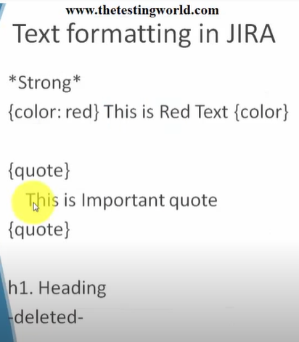

we want to display some text in a quoting format like –

Messaging can not be send.

So I have to type this –

{quote}

Messaging can not be send.

{quote}

**Then it should be quoting format- “**Messaging can not be send”.

Sometimes you want to display something in the heading. it's like a heading format and after that we'll cover up deleted.  Like this sentence -

While testing course search functionality, as we select category and subcategory and click on search, we are not getting expected output.

**So**

**h1.Details**

While testing course search functionality, as we select category and subcategory and click on search, we are not getting expected output.

**=============** then it should be displayed in the heading. like this **--**

**Details**

While testing course search functionality, as we select category and subcategory and click on search, we are not getting expected output.

**=================================================================**

**Delete any word like I want to delete Search from this sentence-** While testing course **search** functionality. So I will do/ type with first and end like this-🡪 -search- then this should be deleted using line Search

While testing course Search functionality.

**============================================================**

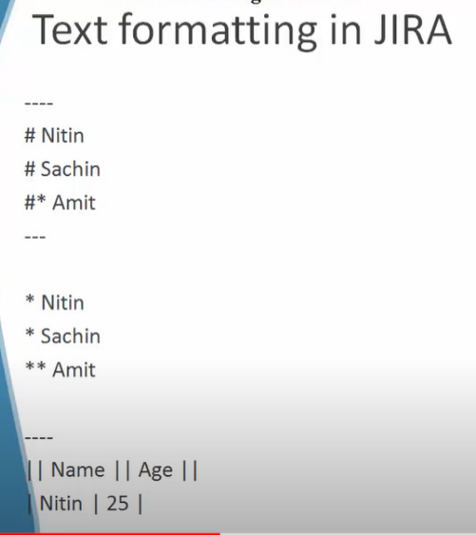

1. If I want to display in the number format. First click on edit Use # and one space before the sentence Like this –

**# Go to application** then it will be changed like this –

1. **Go to application.**

**We can type like this * Go to application. Just type star and write the sentence.**

**2)** sometimes you need to go for sub listing. sub lists means list inside a list. Like first number then sub list using another symbol.

1) After login click on compose button

* Click on rebutton

So to do this –

# After login click on compose button

#* Click on rebutton then click on right button

=============================================

3) To display horizontal line. we just need to mention four hyphen ---- like this.

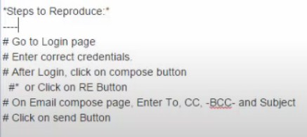

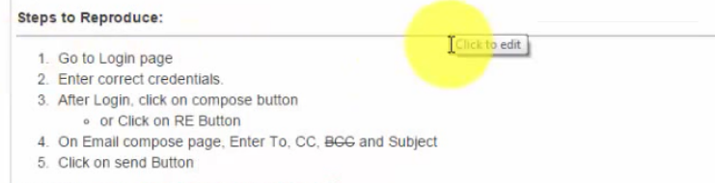

**================================**

Table

To create table –

Here header is given by || double pipe

So ||username||password|| -- This is header that I created in the table.

|uname1|pass1|

|uname2|pass2|

Then it will create a table

=========================================================

Working with JIRA- Reporting a bug in JIRA

===========================================================

========================

KEYS

After giving project name the system automatically will generate a key. You can keep it same or you can change it. This key will be used when you will work on REST API.

Keys are unique to each project. It is used to track what issues belongs to which project. Project keys help you locate issues using search. You can use a project keys to quickly locate issues when you need them using the search box.

**Project Lead** is typically the project primary manager.This person will be the default assignee for new issues . There can only be one project lead.

Question –

1. A project in jira software manages a collection **of issues.**
2. Creating a project also creates a board.
3. Who typically creates new projects for teams ?—**Jira Administrator**